Guidelines on how to connect to a Zoom personal training session or class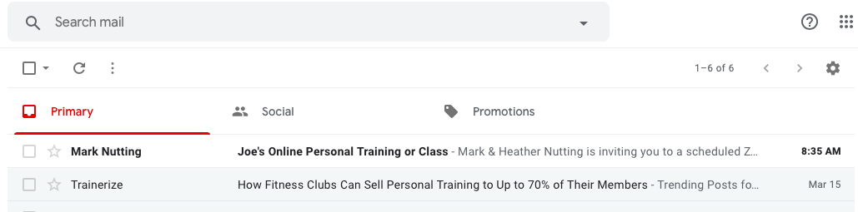
Open the email
Don’t click “Join Zoom Meeting” until appropriate time. So, just save the email until then. Then, a few minutes before that time, open the email again and click the “Join…” link. WAIT!... no need to download.
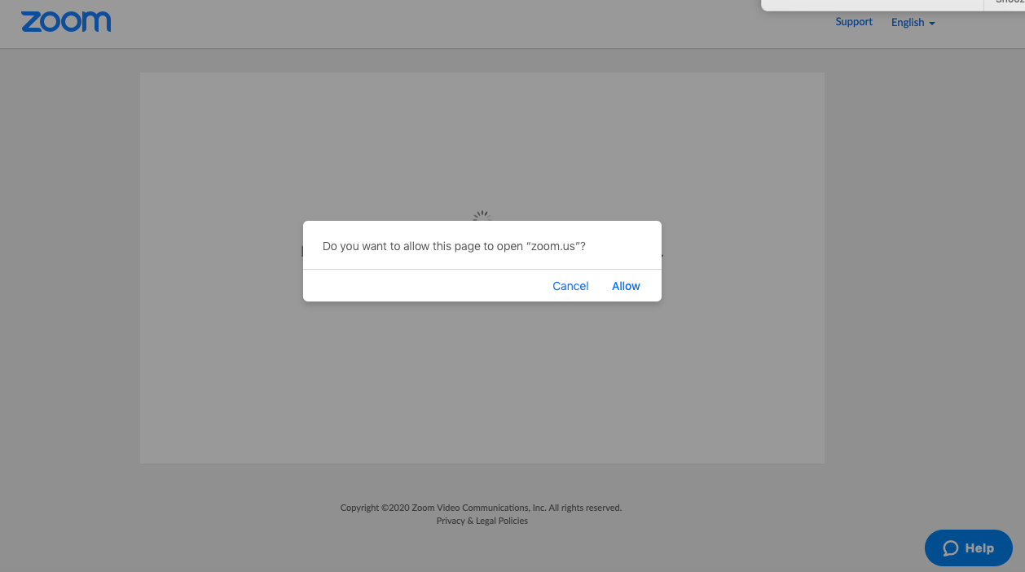
Click Allow! →
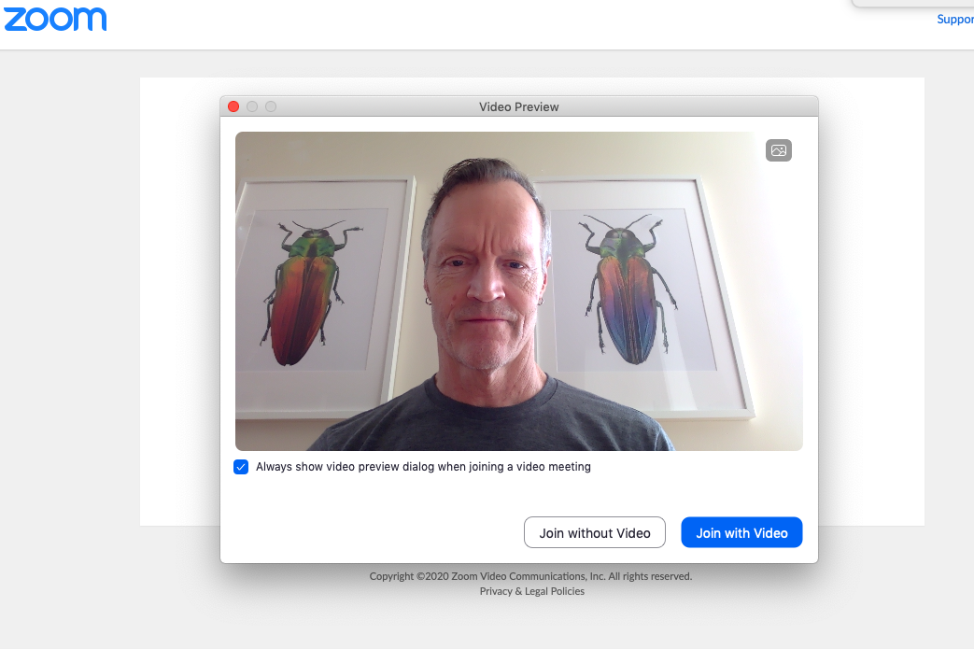
Click Join with Video! →
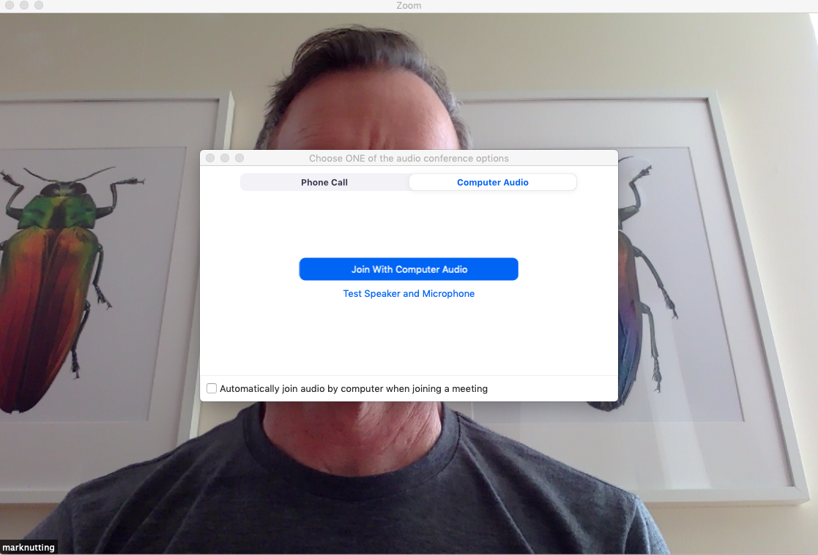
Click Join with Audio!
→

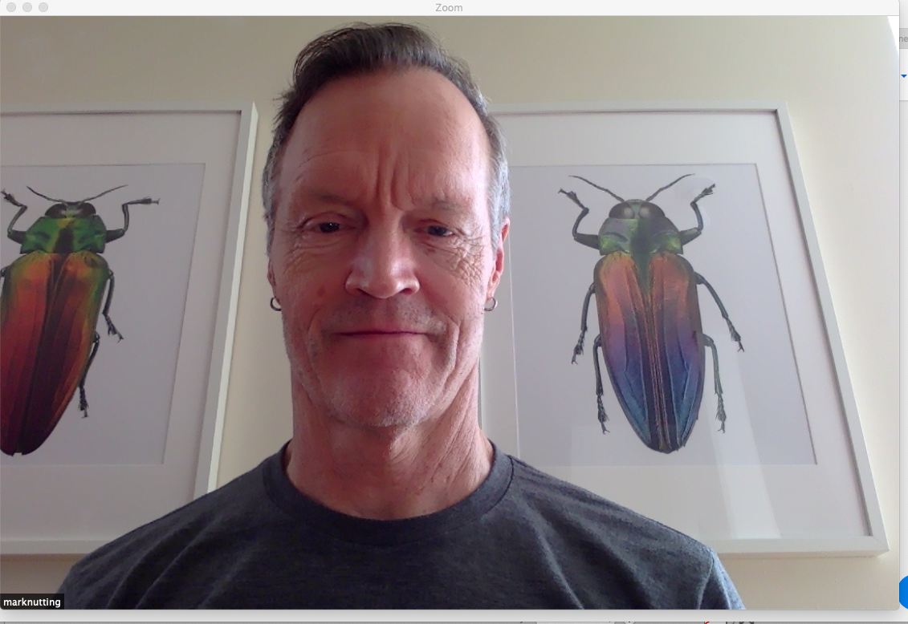
AND YOU SHOULD BE ALL SET TO GO!

NOTE* IF YOU ARE TAKING A LIVE STREAMING CLASS, THE INSTRUCTOR WILL MUTE ALL ATTENDEES UNTIL AFTER THE CLASS
(sounds from others cuts out the instructor’s voice and music)

